Advertising
https://karolakarlson.com/wp-content/uploads/2018/04/airbnb-facebook-ad.gif
Advertisement by Airbnb
Detail | Purpose
Eyeball appearing to read into the mind of the audience | welcomes the audience in to the world of imagination
Vehicles reverse driving | Takes the audience back in time when travelling was not popular.
Black/white scenes | It ruminates ancient times when even the color of motion pictures was not advanced
This is a brand awareness advert that fosters positive perception of travelling thus promoting the business of Airbnb
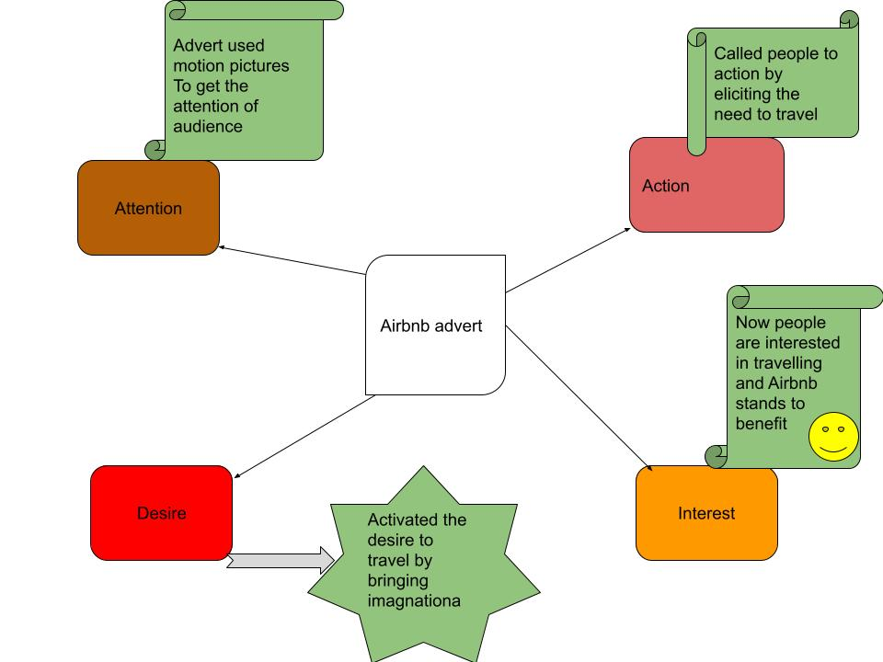
Things that I like from the advert:
- I like the way the advert has used green color to denote growth and expansion of thinking in travel.
- The advert is short while going direct to the point. It may not appear like an interruption from a favorite show. Yet, it achieves its intended purpose of brand awareness.
- Using motion pictures activates the mind of the audience and calls for their attention.
Things that I do not like from the advert:
- The advert tells very little about Airbnb
- It does not highlight the brand’s products or services.
- It fails to use human figures explicitly hence reducing its idea of enhancing human experiences.
Link to the Google drawing: https://docs.google.com/drawings/d/18AmLd6lLnqT0qHrt5NJZ4rAA7TFtLhYQYnxa6fW7lE8/edit?usp=sharing

